Council Assessment Report
Panel Reference | 2017HCC002
DA number | DA/11/2017
LGA | Lake Macquarie City Council
Proposed development | Demolition, commercial premises, residential flat building, and subdivision
Permissibility | Commercial premises and residential flat buildings are permissible within the B4 Mixed Use zone.
Street address | 5 & 7 Edgar Street, Belmont (Lot 10 & 11 Sec B DP 585)  9 & 11 Edgar Street, Belmont (Lot A & B DP 400644)  2, 4 & 6 Sharp Street, Belmont (Lot 4, 5 & 6 DP 12898)  8 & 10 Sharp Street, Belmont (Lot 1 & 2 DP 353066)  32 & 36 Brooks Parade, Belmont (Lot 3 & 4 Sec B DP 585)  38 & 40 Brooks Parade, Belmont (Lot A & B DP 339105)  42 & 44 Brooks Parade, Belmont (Lot 7 & 8 DP 12898)
Zoning | B4 Mixed Use
Applicant/Owner | Applicant: Monteath & Powys Pty. Ltd.  Owner: Allbeach Pty. Ltd., BSE Corporation Pty. Ltd., A Brown, K. Brown and M. Brown
Date of DA lodgement | 4 January 2017
Number of submissions | 30 submissions (29 objections and one 1 in support)  Notified on three occasions:  - 23 January 2017 – 27 February 2017  - 7 September 2018 – 26 September 2018  - 2 January 2020 – 31 January 2020
Integrated development | Natural Resource Access Regulator (NRAR)
External referrals | Transport for NSW (TfNSW)  Ausgrid  Hunter Water Corporation  NSW Police
Recommendation | Approval, subject to conditions of consent
Regional Development Criteria (Schedule 7 of the SEPP (State and Regional Development) 2011 | General development over $30 million  CIV $39 million
List of all relevant s4.15(1)(a) matters | - Environmental Planning and Assessment Act 1979  - Environmental Planning and Assessment Regulation 2000  - State Environmental Planning Policy (Infrastructure) 2007  - State Environmental Planning Policy (Building Sustainability Index: BASIX) 2004  - State Environmental Planning Policy No. 55 – Remediation of Land  - State Environmental Planning Policy No. 65 – Design Quality of Residential Apartment Development  - State Environmental Planning Policy No. 71 – Coastal Protection  - Lake Macquarie Local Environmental Plan 2014 (LMLEP 2014)  - Lake Macquarie Development Control Plan 2014 (LMDCP 2014)
List all documents submitted with this report for the Panel’s consideration | Attachment A: Draft Conditions  Attachment B: Architectural Plans  Attachment C: Landscape Plans  Attachment D: Engineering and Subdivision Plans  Attachment E: Clause 4.6 Exception to Development Standard
Clause 4.6 request/s | An exception to development standards is requested in relation to the maximum building height set under LMLEP 2014 clause 4.3.
Report prepared by | Anna Kleinmeulman, Senior Development Planner
Report date | 28 October 2020

Summary of s4.15 matters  Have all recommendations in relation to relevant s4.15 matters been summarised in the Executive Summary of the assessment report? | Yes
Legislative clauses requiring consent authority satisfaction  Have relevant clauses in all applicable environmental planning instruments where the consent authority must be satisfied about a particular matter been listed, and relevant recommendations summarized, in the Executive Summary of the assessment report? | Yes
Clause 4.6 Exceptions to development standards  If a written request for a contravention to a development standard (clause 4.6 of the LEP) has been received, has it been attached to the assessment report? | Yes
Special Infrastructure Contributions  Does the DA require Special Infrastructure Contributions conditions (S7.24)? | Not applicable
Conditions  Have draft conditions been provided to the applicant for comment? | Yes

Executive summary
Consent is sought for a mixed use development comprising,
- demolition of existing structures,
- 120 apartments across four towers,
- 707m² of commercial/retail space,
- basement car parking,
- subdivision of the amalgamated site to excise the portion north of the drainage channel not developed under this application.
The application includes a submission under clause 4.6 of Lake Macquarie Local Environmental Plan 2014 seeking a variation to the 22m building height applicable to the site. This variation is considered worthy of support.
Consultation with Transport for NSW, Ausgrid, Hunter Water was undertaken during the assessment. No objections were raised in relation to the proposal. General Terms of Approval have been issued by NSW Water for dewatering of the site.
Submissions were received from 19 parties across three notification periods. Of these, one submission was in support of the proposal whilst 18 parties raised concerns.
The site is constrained by flooding, acid sulfate soils and Aboriginal heritage. These matters have been adequately addressed and do preclude development of the site.
The development has been assessed to be compliant with applicable State, Regional and Local Environmental Planning Instruments and Policies, in accordance with Section 4.15(1) of the Environmental Planning and Assessment Act 1979. Planning instruments addressed within this report include:
- Environmental Planning and Assessment Act 1979
- Environmental Planning and Assessment Regulation 2000
- State Environmental Planning Policy (Infrastructure) 2007
- State Environmental Planning Policy (Building Sustainability Index: BASIX) 2004
- State Environmental Planning Policy No. 55 – Remediation of Land
- State Environmental Planning Policy No. 65 – Design Quality of Residential Apartment Development
- State Environmental Planning Policy No. 71 – Coastal Protection
- Lake Macquarie Local Environmental Plan 2014 (LMLEP 2014)
- Lake Macquarie Development Control Plan 2014

The development is considered to be in the public interest and worthy of support subject to conditions.

Reasons for determination
The development has been assessed against the relevant matters for consideration applicable to the land and proposed development as outlined in Section 4.15 of the Environmental Planning and Assessment Act 1979 as follows:
- the development meets the requirements of the Lake Macquarie Local Environmental Plan 2014 and other relevant environmental planning instrument inclusive of a clause 4.6 submission exception to the development standard under clause 4.3;
- consideration has been given to proposed instruments which have been the subject of public consultation;
- the development generally complies with Lake Macquarie Development Control Plan 2014 with any variations to the controls outlined and justified within this assessment report;
- considering the likely impacts of the development on the natural and built environments, the development is considered to provide balanced and appropriate outcomes;
- the suitability of the site for the development, including characteristics and constraints of the land have been considered and it was found the land as being suitable for the development;
- matters of public interest have been considered in relation to social, economic and environmental outcomes.
Based on the balance of the matters considered, the application is recommended for approval. Details of the assessment are contained in the assessment report below.

Community interest
The assessment of the proposed development under Section 4.15(1) of the Environmental Planning and Assessment Act 1979 has considered community views. The application was notified in accordance with the Council’s Community Participation Plan as adopted by Lake Macquarie City Council.
The application was notified on three separate occasions following the original lodgement and submission of amended plans, as follows:
- 23 January 2017 to 27 February 2017
- 7 September 2018 to 26 September 2018
- 2 January 2020 to 31 January 2020
From the notification periods 30 public submissions were received in relation to the proposed development.
The matters raised in these submissions have been considered as part of the assessment of the proposed development. For detailed comment regarding the matters raised in the submissions refer to Section 4.15(1)(d) of this report.

Site, context and development history

Background
The application was lodged with Council on 3 January 2017.
The application was reported to the Regional Planning Panel (RPP) on 23 November 2017 with Council Officers recommending refusal due to design issues and isolation of 44 Brooks Parade. The Panel deferred the determination to allow the applicant to negotiate with the isolated lot and address the design issues.
The application was again referred to the RPP on 18 October 2018 and again recommended for refusal due to significant departures from the building height applicable to the site as well as non-compliance with the Apartment Design Guide and Council’s DCP. The RPP deferred the determination of the application requiring the applicant to workshop the design with Council’s (SEPP 65) Design Review Panel (DRP) and address potential inundation of the basement car park.
Several meetings have been held with the DRP, Council officers and the applicant to work through design issues and have resulted in the current proposal recommended for approval.

Site and locality
The site is located along the eastern shores of Lake Macquarie, within the town centre of Belmont.
The site has an open stormwater channel traversing from Edgar Street to Brooks Parade. Mature fig trees are located along part of the Edgar Street frontage.
The site is an amalgamation of 15 lots. Figure 1 details the site as bounded in yellow and red, with the red bounded area south if the drainage channel to incorporate the proposed mixed-use development and the yellow area north of the drainage channel to be a lot excised via subdivision. It is anticipated the land bounded in yellow will logically be amalgamated with land to the north to create a large development site.
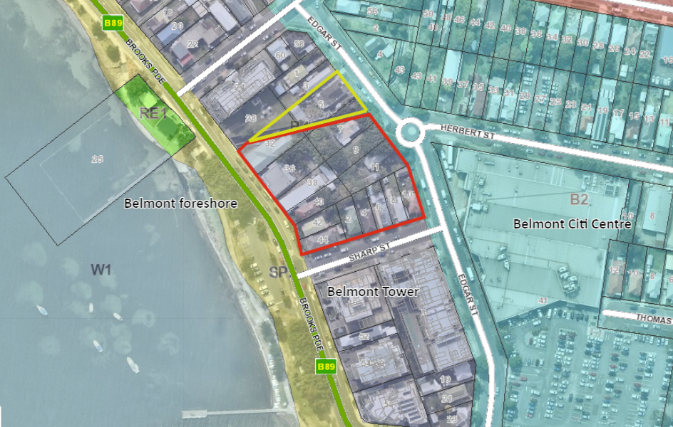
Figure 1 – Site, surrounding land uses and zoning
The site is generally flat (maintaining existing ground levels of 0.93m to 1.78m AHD) and is situated in a flood planning area (including sea level rise) under LMLEP 2014.
The site consists predominantly of older building stock incorporating single storey dwelling houses and small shops which are to be demolished to facilitate the development.
North of the site is Hunter Water Corporation (HWC) owned land, which includes a sewer pump station. Further to the north of the site is a five-storey mixed use development constructed in 2008 known as ‘Santorini’.
To the south-east of the site is Belmont Citi Centre, a shopping centre including a Coles Supermarket which has its loading dock area opposite the site. The Belmont Town Centre is located further east and includes a range of services including schools, medical facilities, banks, a post office, sporting facilities, library and major public bus routes.
South of the site are several mixed use developments including:
- Belmont Towers, an eight-storey residential flat building constructed in the 1960’s,
- Belmont Central Apartments, a six-storey mixed use development approved in 2009,
- Deck Apartments, a six-storey mixed use development approved in 2008, and
- Wharf Apartments, a six-storey mixed use development with mezzanine approved in 2015.
Belmont foreshore and Lake Macquarie are located west of the site.

Proposal
The application proposes a mixed-use development at the site comprising the following:
- demolition of existing structures across the site,
- 120 apartments across four towers, ranging from six-seven storeys plus rooftop terraces
- 707m² of commercial/retail space,
- two levels of basement car parking, providing residential and commercial parking,
- landscaping and public domain works,
- lot consolidation and subdivision to excise the portion north of the drainage channel not developed under this application.

Section 4.15: Potential matters for consideration
Applicable State, Regional and Local Environmental Planning Instruments and Policies are detailed hereunder. Where not explicitly detailed, it is considered those instruments or policies are not relevant to the proposal.

Section 4.15 (1) (a) (i) the provisions of any EPI’s

State Environmental Planning Policy (State and Regional Development)
The proposal is identified as regionally significant development under Part 4 Regionally significant development and Schedule 7 of the SEPP due to the capital investment value exceeding $30 million.
The Hunter and Central Coast Regional Planning Panel will be the consent authority for the application.

State Environmental Planning Policy No. 55 – Remediation of Land
Under clause 7 of the SEPP a consent authority must not consent to the carrying out of any development on land unless:
- it has considered whether the land is contaminated, and
- if the land is contaminated, it is satisfied that the land is suitable in its contaminated state (or will be suitable after remediation) for the purpose for which the development is proposed to be carried out, and
- if the land requires remediation to be made suitable for the purpose for which the development is proposed to be carried out, it is satisfied that the land will be remediated before the land is used for that purpose.

The lots comprising the development site consist of existing dwelling houses and commercial premises. Council’s records do not identify any historic land uses or notices in relation to the land being contaminated.
An Environmental Site Assessment was undertaken by Regional Geotechnical Solutions (reference RGS01385.1-AD) for the development. The preliminary investigation discovered minor levels of contamination by heavy metals and pesticides all of which were at concentrations below the adopted criteria for residential land use. One sample also contained asbestos material, likely as a result of previous building works. The report recommended that additional sampling and analysis is undertaken in the area where the asbestos was discovered and affected soil be removed from the site as asbestos waste. All other soil to be excavated from the site is considered VENM and can be disposed to a site approved to receive fill material.
The investigations concluded the site is appropriate for the development with regards to contamination resulting from past or present land use.

State Environmental Planning Policy No. 65 – Design Quality of Residential Apartment Development
Clause 28(2) of the SEPP requires the consent authority to consider:
- The advice from a design review panel,
- The design quality of the development when evaluated in accordance with the design quality principles, and
- The apartment design guide (ADG).
Additionally, clause 30(2) states that development consent must not be granted if, in the opinion of the consent authority, the development or modification does not demonstrate that adequate regard has been given to:
- The design quality principles, and
- The objectives specified in the Apartment Design Guide for the relevant design criteria.
The development has been reviewed by Council’s DRP on five separate occasions, most recently in February 2020. The endorsed recommendations are contained in whole within Appendix 1. The DRP noted that although the development design had made a number of significant improvements there remained a number of concerns, particularly in relation to building height, building aesthetics and building separation.
The latest amendments to the design have not been reviewed by the DRP, however a summary of the previous matters raised and the design response is provided as an addendum within Appendix A. The final plans are considered to adequately address the concerns that were raised.
The applicant has provided a detailed assessment of the development against the design quality principles and the provisions of the ADG. Council has reviewed this document and is satisfied it accurately details the proposal and that the matters contained in clause 30(2) are adequately addressed. A copy is included in Appendix B.
The development is considered to be generally consistent with the provisions of the Apartment Design Guide. A summary of key components not specifically covered in the discussion under DCP requirements is detailed below:
ADG Key standard | Proposal
4B Ventilation | The development achieves cross ventilation to 76% of units compliant with ADG requirements.
4C Ceiling heights | Ceiling heights are in accordance with the minimum specified under ADG. 2.7m for habitable rooms and 2.4 for non-habitable rooms
4D Apartment size | Apartment sizes exceed the minimum area requirements for all bedroom typologies
4F Circulation | A maximum of 6 units are accessed from central circulation spaces. Circulation spaces are provided with natural light.
4G Storage | Each unit is provided with internal storage cupboards in addition to walk in wardrobes. Additional secure storage is provided within the foyer/circulation spaces of Building A as well as within the basement which will be allocated to units. Minimum storage requirements are met.

State Environmental Planning Policy No. 71 – Coastal Protection
The site is located within the SEPP 71 Coastal Zone. The application is to be assessed having regard to the aims of the SEPP and the matters for consideration as listed under Clause 8. These maters are to be taken into account by a consent authority when it determines a development application to carry out development on land to which tis Policy applies.
The site is an area previously developed for low density housing. The site is adjoined on the northern, eastern and southern sides by low and high-density forms of residential development as well as commercial/retail development. To the west is Brooks Parade and the Belmont foreshore being a formalised public space.
As the development has no direct boundary with the lake foreshore and the public space, it has negligible impacts. This includes consideration of coastal processes, ecology, and the integrity/resilience of the environment. Further, a Due Diligence report has addressed Aboriginal heritage, with no concerns raised.
The development has been assessed with regard to water quality through a stormwater management plan, a soil and water management plan and General Terms of Approval (GTAs) issued by NSW Water.
In terms of public access, open space and amenity, the development does not have any detrimental impacts. The detached building forms and the separation from the Belmont foreshore by Brooks Parade minimises impacts from wind tunnelling, allows view sharing, maintains public access and amenity.
SEPP (Coastal Management) 2008 came into effect on 3 April 2018. Clause 21(1) Savings and Transitional Provisions of the SEPP (Coastal Management) 2018 states it does not apply to a development application lodged but not finally determined prior to commencement of the policy. The development application was lodged on 2 January 2017.
Notwithstanding the above, the site falls within the coastal environmental area and the coastal use area under this SEPP. Consideration has been given to the matters contained within Division 3, 4 and 5 of the SEPP. The development does not raise any additional matters of concern under this plan.

State Environmental Planning Policy (Building Sustainability Index: BASIX) 2004
BASIX Certificate no. 747948M_03 has been submitted in support of the development.

State Environmental Planning Policy (Infrastructure) 2007

Part 3, Division 5, Subdivision 2 Development likely to affect an electricity transmission or distribution network
Exposed overhead power lines run along the Brooks Parade and Sharp Street frontages of the site and will fall within 5m of the development.
In accordance with clause 45(2) of the SEPP the application was referred to Ausgrid for comment. Ausgrid raised no objection to the development, subject to minimum clearances to electrical infrastructure being achieved. A copy of Ausgrid’s correspondence is attached in Appendix C.
Conditions of consent are recommended to ensure compliance with Ausgrid’s requirements. Where minimum clearances to overhead infrastructure cannot be achieved, it will be necessary for power lines to be relocated underground.

Part 3, Division 17, Subdivision 2 Development in or adjacent to road corridors and road reservations
Brooks Parade is a classified road under the care and control of Transport for NSW (TfNSW). The development also triggers traffic generating development provisions as the loading dock access is located within 90m of the intersection with Brooks Parade and will service a residential flat building containing more than 75 dwellings.
The development was referred to TfNSW (formally NSW Roads and Maritime Service) who advised they have no objections to the proposed development and considered that there will be no significant impact on the nearby classified (State) road network. A copy of TfNSW’s correspondence is included in Appendix C.
In accordance with clause 101 of the SEPP, the consent authority must not grant consent to development on land that has frontage to a classified road unless it is satisfied that:
- Where practicable and safe, vehicular access to the land is provided by a road other than the classified road, and
- The safety, efficiency and ongoing operation of the classified road will not be adversely affected by the development as a result of:
    - The design of the vehicular access to the land, or
    - The emission of smoke or dust from the development or
    - The nature, volume or frequency of vehicles using the classified road to gain access to the land, and
- The development is of a type that is both sensitive to traffic noise or vehicle emissions, or is appropriately located and designed, or includes measures, to ameliorate potential traffic noise or vehicle emissions within the site of the development arising from the adjacent classified road.
The development is serviced by vehicular entry points from Edgar Street and Sharp Street, neither of which are classified roads.
The application is supported by an acoustic assessment that provides recommendations regarding building materials and methods to reduce road noise within residential apartments to achieve acceptable noise levels (i.e. laminated glass with acoustic seals on bedroom windows, solid core doors where applicable and provision of insulation). Conditions of consent are recommended to ensure compliance with the report’s recommendations.

Lake Macquarie Local Environmental Plan 2014

Part 2 – Permitted or prohibited development
The development is a mixed-use development incorporating land uses defined under the LMLEP 2014 as residential flat building and commercial premises. Each of these land uses is permissible in the B4 Mixed Use zone subject to development consent.
The objectives of the B4 zone are:
- To provide a mixture of compatible land uses,
- To integrate suitable business, office, residential, retail and other development in accessible locations so as to maximise public transport patronage and encourage walking and cycling.
- To enable development that complements and enhances the core retail function and trading performance of Zone B2 Local Centre and Zone B3 Commercial Core.
The development provides a mix of compatible land uses including residential, business and retail in an accessible location and is consistent with the above objectives.

Clause 2.6 Subdivision – consent requirements
The site currently incorporates 15 individual lots. The application includes consolidation of these lots and a subdivision to excise the portion of land north of the drainage channel.

Clause 2.7 Demolition requires development consent
The application includes demolition of existing structures that currently occupy the site. This includes dwellings and associated outbuildings and retail premises.

Clause 4.1 Minimum subdivision lot size
There is no minimum lot size prescribed under LMLEP 2014 in relation to the land.
The development includes consolidation of the 15 lots, with subsequent subdivision to create two lots. The resultant lot sizes will have areas of 6379m² (the site) and 1254m² (residual lot).

Clause 4.3 Height of buildings
The objectives of the building height standard is to ensure the height of buildings are appropriate for their location and to permit building heights that encourage high quality urban form.
A 22m maximum building height applies to the site. The development includes four residential towers, each of which exceed the maximum building height to varying degrees as detailed in Table 1 and Figure 1.
The most significant variation relates to Building A where a variation of 4.54m or 20.6% is proposed and relates to a small portion of the top residential level. The height variations for Buildings B, C and D range from 1.56m (7.1%) to 0.83m (3.8%). The exceedance in all instances is attributed to awnings over rooftop terraces and plant equipment/lift overruns as demonstrated in Figure 2.
 | Building height | Variation sought
Building A | 26.54m | 4.54m (20.6%)
Building B | 23.56m | 1.56 (7.1%)
Building C | 22.92m | 0.92m (4.2%)
Building D | 22.83m | 0.83m (3.8%)
Table 1 – Building height variation summary
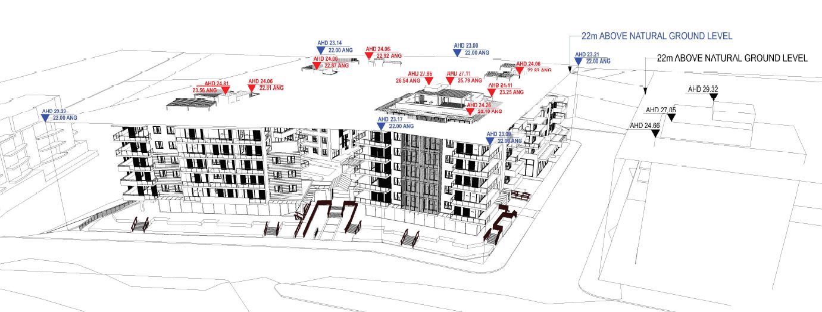
Figure 2 – Building height variation perspective
A written request to vary the building height development standard under clause 4.6 - exceptions to development standards has been submitted in relation to the proposed height variations.

Clause 4.6 Exceptions to development standards
The objectives of the clause is to provide an appropriate degree of flexibility in applying development standards to achieve better outcomes than would otherwise be achieved through strict compliance. Clause 4.6 is an appropriate mechanism to vary the maximum height limit set under clause 4.3 height of buildings of LMLEP 2014.
Development consent must not be granted for development that contravenes a development standard unless the consent authority has considered a written request from the applicant that seeks to justify the contravention by demonstrating:
- that compliance with the development standard is unreasonable or unnecessary in the circumstances of the case, and
- that there are sufficient environmental planning grounds to justify contravening the development standard.
The applicant has submitted a written request under clause 4.6 to vary the 22m maximum height limit applying to the site.
In response to justifying that compliance with the development standard is unreasonable or unnecessary in the circumstances of the case, the applicant refers to the principles set out by Chief Justice Preston in Webhe v Pittwater Council [2007] and Initial Action Pty. Ltd. v Woollara Municipal Council [2018]. In particular, it is argued the development achieves the objectives of the standard notwithstanding non-compliance with the standard as follows,
- The height of buildings is appropriate for their location:
  - the site is located within a part of Belmont identified as a key growth area and an economic centre,
  - surrounding developments have heights commensurate with the proposal. The development has heights ranging from 22.83m to 26.54m. In comparison to the Belmont Tower development which has a height of 29m measured to the top of the lift overrun, 27m to the top of the enclosed rooftop terrace and 25m to the main building,
  - Building form is reflective of surrounding development and in keeping with the locational attributes, particularly Belmont Towers,
  - The site is currently underutilised and presents an opportunity to fulfil the vision for a sustainable and emerging vibrant commercial precinct,
  - The proposal will increase housing density and diversity, improve streetscape interfaces and enhance connectivity and amenity within a well serviced location,
  - The additional height does not create any significant overshadowing impacts.
- Permit building heights that encourage high quality urban form:
  - The development is of high quality urban form and responds to the constraints of the site including flooding and sea level rise constraints,
  - The development provides four freestanding buildings to reflect the size and nature of the site,
  - The proposal provides setbacks that are consistent with the Belmont Area Plan, and the nine design quality principles identified in SEPP 65,
  - The proposal is supported by an Urban Design Report that outlines how the proposed building form and height of Building A mirrors and balances the development of Belmont Towers,
  - The development is contextually appropriate when viewed from a distance and in particular the Lake as shown in perspectives.

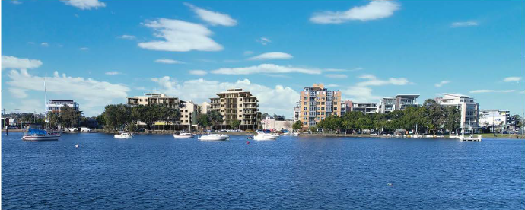
Figure 3 - Photomontage of development as viewed from the Lake
- The additional height of the four towers includes the provision of high-quality rooftop landscape design which enhances the architectural form and provides residents with functional and sustainable spaces.
The applicant also argues that whilst the underlying object or purpose of the standard would not be defeated or thwarted if compliance was required, the development provides a better outcome than if compliance was strictly applied and therefore compliance is unreasonable.
In relation to establishing there are sufficient environmental planning grounds to justify contravening the development standard the applicant submits the following,
- The objectives of the standard are achieved as detailed above,
- The site is in the Belmont Town Centre and is identified in both regional and local planning strategies as a major town centre capable of higher density development,
- The scale of development is consistent with regional strategies and plans for higher densities at key public transport nodes,
- The scale of the development is consistent with approved developments in the area,
- The additional height does not create any significant additional overshadowing impacts,
- The additional height is able to meet relevant design standards in regards to solar access and cross ventilation within apartments.
Council considers the applicant’s written request has appropriately addressed the contravention of the building height standard and provided sufficient justification that compliance with the development standard is unreasonable and unnecessary in the circumstances of the case, and there are sufficient environmental planning grounds to justify contravening the development standard.
In consideration of the clause 4.6 variation, Council have considered the development will be in the public interest because:
- it is consistent with the objectives of the building height standards by providing buildings that are appropriate for their location and are of high quality urban form,
- it is consistent with the objectives of the B4 Mixed Use zone by providing a mixture of compatible land uses in a well service location,
- it is contextually consistent with surrounding development; and
- it does not lead to significant adverse impacts on local amenity.
Consideration also needs to be given to whether the variation raises any matter of significance for state or regional environmental planning, and the public benefit of maintaining the standard.
There are no anticipated impacts on state or regional planning associated with supporting the proposal and height variation. The height exceedances relate mainly to roof structures over rooftop communal spaces and associated plant equipment. The increased height, particularly of Building A provides a transition to the neighbouring Belmont Towers development and will appear in context with the surrounding development.
The development meets the objectives of the B4 zone, as well as the objectives relating to building height within clause 4.3. It is therefore considered there is no public benefit in maintaining the development standard in this instance.
As the consent authority for the development application the Hunter and Central Coast Regional Planning Panel have delegation to determine the clause 4.6 variation.

Clause 7.1 Acid sulfate soils
The site is mapped as being affected by Class 2 acid sulfate soils where works are below the natural ground surface or will interrupt the water table and may impact upon affected soils.
The development will intercept the water table in order to construct the basement car park, excavating to depths in order of 5m and disturbing more than 1000 tonnes of soil.
A geotechnical assessment of the site identified potential acid sulfate soils (PASS) are encountered between 2.4 and 4.5m.
A preliminary Acid Sulfate Soils Management Plan has been prepared and conditions will be imposed to ensure works are undertaken in accordance with the plan.

Clause 7.2 Earthworks
Before granting consent, the consent authority must consider the implications of the development on the environment/locality in relation to earthworks.
The development site is generally flat however earthworks are required to construct the development, in particular the basement car park. The depth of excavation is approximately 5m.
The area to be excavated is bound by the drainage channel to the north, Edgar Street to the east, Sharp Street to the south, and Brooks Parade to the west. Therefore, other than infrastructure/assets, the development will have minimal impact on adjoining properties.
Given the proximity to adjoining buildings, preparation of a dilapidation report is recommended as a condition of consent.
With regard to intercepting the water table and its potential impact on water cycle processes and quality, the development has been granted integrated approval by NSW Water for dewatering the site Section 90 of the Water Management Act, 2000. NSW.
The development has been assessed from an erosion prevention and sediment control perspective, with conditions recommended.
The development has also been considered in relation to Aboriginal heritage, with a Due Diligence report having been referred to Aboriginal community groups and no submissions received. See discussion under clause 7.7.
Earthworks proposed are considered acceptable subject to the imposition of conditions.

Clause 7.3 Flood Planning
The site is mapped as being affected by flooding, including sea level rise.
The consent authority is required to consider the implications of the flooding characteristics on life and property with respect to the development and ensure the development does not adversely affect flooding behaviour.
Based upon Council’s flood planning policy, minimum floor levels applicable to the development are as follows:
- commercial / retail – 2.36m AHD
- residential – 2.82m AHD
Proposed finished floor levels are generally compliant with the above.
Commercial / retail spaces in Building D are proposed to have split floor levels with the lower level being at street level (1.27AHD) and non-compliant with the above FFL. These spaces are to be adaptable and include fittings/fixtures that can easily be relocated in the event of a flood or are able to be immersed. Details of the fittings and split floor levels has not been specified in the application. Council is supportive of the alternate outcome in principle Further detail will need to be submitted with the applications to fit out these premises.
The entry to the basement car park is also below the probable flood level. To prevent floodwaters entering the basement, the development will be fitted with a flood barrier system. Council raises no objections to this approach and has recommended conditions of consent.

Clause 7.7 Development on sensitive Aboriginal landscape areas
The land is mapped as part of Council’s Sensitive Aboriginal Landscape Area Map as shown in Figure 5.
Figure 4 - Sensitive Aboriginal landscape as mapped under LMLEP 2014
The applicant provided a Due Diligence Report. The report was referred to local Aboriginal communities for 28 days as per sub-clause (8)(b); no submissions were received.
Council’s Heritage Planner confirmed the report does not identify any Aboriginal objects or areas of potential archaeological deposit within proximity to the proposed development, with the area found to fit the definition of disturbed land. The officer was satisfied the report is adequate for the purposes of assessing impacts to Aboriginal heritage.

Clause 7.10 Residential development in certain business zones
Clause 7.10 of LMLEP 2014 requires the consent authority to be satisfied the residential flat building/s are part of a mixed-use development in which all or part of the ground floor of the building facing the primary street frontage has an active frontage and is to be used for the purpose of commercial premises or health services facility.
The development includes commercial floor space at ground/podium level in three of the four buildings. These spaces have frontage to Edgar Street, Sharp Street and Brooks Parade and provide activation to all three street frontages. This is consistent with the Block Plan contained within the Belmont Town Centre Area Plan (LMDCP 2014).

Clause 7.21 Essential services
The consent authority must not grant consent unless it is satisfied the required essential services are available to serve the development.
The development has demonstrated the site is capable of being provided with required essential services and infrastructure including water, sewer, electricity, stormwater and vehicle access.

Section 4.15 (1) (a) (ii) the provisions of any draft EPI
State Environmental Planning Policy (Coastal Management) 2018 came into effect on 3 April 2018. This is addressed under SEPP 71 – Coastal Protection.

Section 4.15 (1) (a) (iii) DCP’s

Lake Macquarie Development Control Plan (DCP) 2014

Part 4: Development in Business Zones

2.1 Site Analysis
Adequate site analysis has been submitted.

2.2 Scenic values
In lieu of a formal visual impact assessment, the applicant has provided photomontages (refer to figures 5-10) of the development as viewed from various locations within the surrounding area.
Council’s Scenic Management Guidelines locate the site within Scenic Management Zone 5 - Lake surround, high settlement. This zone has a desired future character of encouraging development appropriate for town centres, including compact, higher density development with a mix of retail, business and residential uses, active street frontages, and a pleasant atmosphere for pedestrians and attractive streets. The character of buildings and the surrounding landscape should reflect the lakeside location and the popularity of these areas as social and recreational destinations. Physical and visual connections to the Lake are important and should be preserved and enhanced.
The development is considered to be consistent with the expected visual impact for the locality and fit within the existing urban landscape without having a detrimental impact on the scenic values of the area. It is acknowledged visual impacts occur however these are largely unavoidable due to the overall scale of the development.
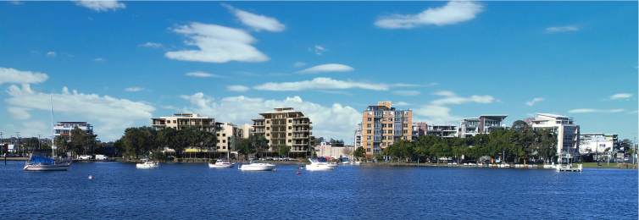
Figure 5 – Perspective of development viewed from the Lake
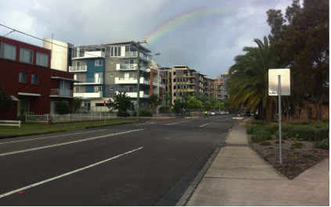
Figure 6 – Perspective of development viewed from Brooks Parade - south
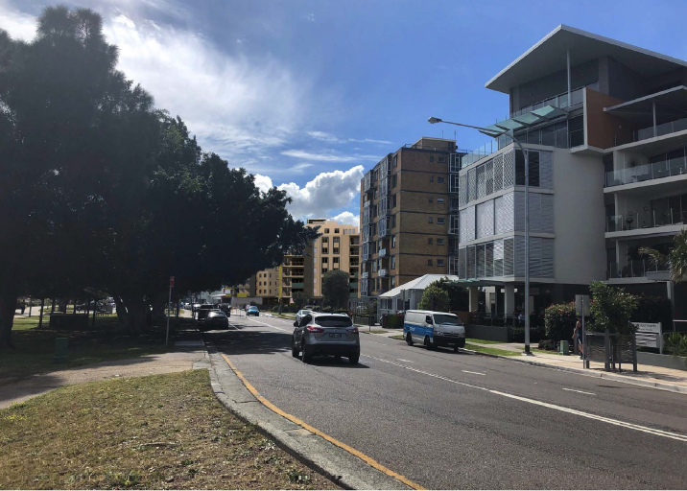
Figure 7 – Perspective of development viewed from Brooks Parade - north

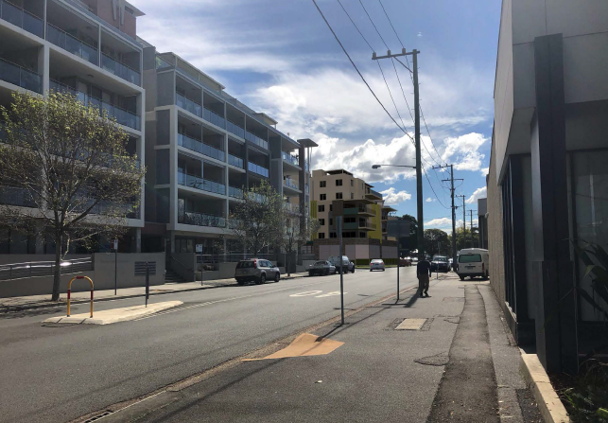
Figure 8 – Perspective of development viewed from Edgar Street - north
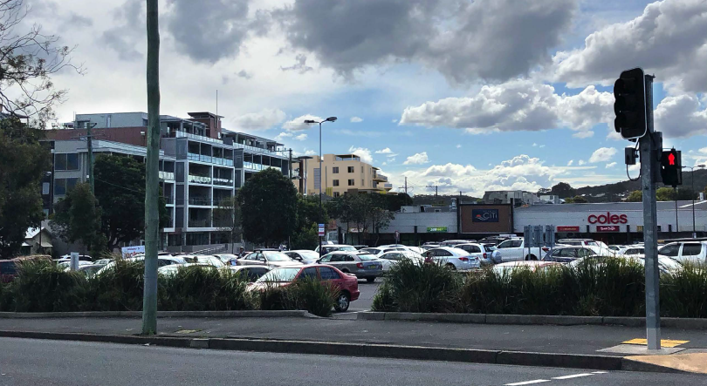
Figure 9 – Perspective of development viewed from Belmont Citi Centre car park
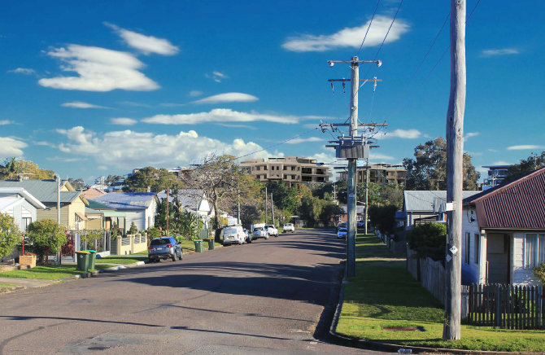
Figure 10 – Perspective of development viewed from Albert and Marks Street

2.3 Geotechnical
The site is identified as geotechnical zone T6 (low risk).
A geotechnical report has been submitted and deemed satisfactory by Council’s Development Engineer. This report was prepared when the development contained a single basement level and will need to be updated prior to any works commencing on the site to ensure the recommended construction methodologies are adequate for the second basement level. Council’s Development Engineer has raised no concerns and conditions are recommended to capture the above reporting requirement to requiring construction plans to be endorsed by the geotechnical Engineer.

2.4 Cut and fill
Excavations to depths of approximately 5m below the existing ground level are proposed for the two levels of basement car parking proposed. The upper level of the basement car park is only partially below existing ground levels owing to the proposed podium level.
The proposed earthworks are considered appropriate and acceptable.

2.6 Contaminated land
Refer to assessment under SEPP 55 – Remediation of land.

2.8 Stormwater management
The development proposes a stormwater management design that captures stormwater within the site and discharges it to the existing stormwater rechannel and street network. The design includes stormwater harvesting for re-use within the development.
Council’s Development Engineer has assessed the stormwater management system and deemed it appropriate for DA purposes. A condition of consent will be imposed to ensure detailed engineering design plans are submitted for the system as part of the construction certificate (CC) process.

2.9 Catchment flood management and 2.10 Lake flooding and tidal inundation
Refer to assessment under clause 7.3 of LMLEP 2014.

2.11 Natural water systems
The stormwater management plan submitted with the application includes adequate water quality controls to ensure receiving water bodies are not adversely affected.
Excavation to construct basement levels of the development will intercept the water table, as identified in the geotech report submitted with the application. In accordance with Section 90 of the Water Management Act 2000, these works require integrated approval from NSW Water for dewatering the site. Accordingly, the application was referred to NSW Water who has granted GTAs for these works.

2.14 Preservation of trees and vegetation
The site consists of a mix of native and exotic vegetation, none of which warrants restrictions on development. All existing vegetation on the site is to be removed as a consequence of the basement carpark and podium.
No objection is raised to the proposed vegetation removal. The compensate for the vegetation removal, the development includes deep soil planting around the perimeter of the site.

2.16 Aboriginal heritage
Refer to assessment under clause 7.7 of LMLEP 2014.

2.18 Social impact
A Social Impact Assessment has been submitted and deemed satisfactory by Council’s Social Planner.
To ensure appropriate use of development by future residents, an Operational Management Plan will be conditioned and require the following items to be addressed:
- How communal spaces will be operated/managed,
- What information will be provided to new residents,
- Whether there are programs/activities planned to encourage interaction between the residents and with the wider community; and
- How a sense of ownership/belonging is planned to be fostered.

2.19 Economic impact
An Economic Impact Assessment has been submitted and Council has no concerns regarding the economic impacts of the development.
The development will provide economic benefits to the City, and particularly Belmont, through jobs created during the construction phase. Post construction, the development will provide an increase in commercial floor space within the Belmont Town Centre, along with new residents further strengthening the dynamism of commercial activity in the centre.

2.20 Lot amalgamation
The development amalgamates 15 lots in an orderly pattern, which is consistent with the block controls under Belmont Town Centre Area Plan.
No lots are isolated as a result of the development.

2.21 Utility infrastructure
The development includes the provision of an electrical substation located within the building on the Edgar Street frontage. Details of fire hydrant infrastructure has not been indicated on the submitted plans. To ensure that this is suitably positioned and does not detract from the building design or streetscape, this detail shall be submitted to Council prior to the issue of a Construction Certificate.

3.4 Streetscape improvements
The development will incorporate public domain works within the footpath areas of Brooks Parade, Sharp Street and Edgar Street including footpath, street trees and bus shelter.
Streetscape improvements within the public domain will be in accordance with the Belmont Streetscape Master Plan.
The landscaping plans have been reviewed by Council’s Landscape Architect who raises no objections to the proposed works and conditions of consent are recommended.

3.5 Non-discriminatory access
Equitable access is provided to all parts of the development through the provision of access ramps and lifts. A Disability Access Report has been submitted with the application detailing the development is capable of compliance with the applicable standards.
Conditions of consent are recommended requiring certification of the construction plans by an Access Consultant to ensure the development achieves compliance with the applicable standards.

3.6 Lighting
Details of lighting have not been provided.
Conditions of consent are proposed to ensure adequate lighting is provided throughout the development in a manner that provides for adequate safety and security whilst not impacting upon the amenity of neighbouring residents.

4.2 Ground floor levels
Ground floor levels of the development are raised up to 1.4m above existing ground level to accommodate Council’s specified flood planning levels.
The transition between street level and ground floor levels within the development is addressed in several ways including,
- Commercial tenancies within Building D on the corner of Sharp Street and Edgar Street are designed with a portion of the floor area being at street level to improve activation.
These areas will be able to be vacated in the event of a flood.
- On Brooks Parade, Buildings A and B are separated from the street by decking and landscaping.
The provision of decking will allow for users with the commercial tenancies to flow out in to these spaces and activate the street frontage.
Stepped retaining walls accommodating landscaping are provided around the remaining perimeter of the podium level.

4.3 Ground floor entries
Entries to the commercial tenancies are easily identified. The tenancies in Building D are accessed directly from the footpath from Sharp and Edgar Streets. The tenancies fronting Brooks Parade are set on the podium level and access via the deck forecourt area.
Apartments are access via foyer areas located on the ground floor of each building and additional access points to the central podium communal open space is available from Brooks Parade, Sharp Street and Edgar Street.
Equitable non-discriminatory access is provided to the podium level through ramps and lifts.

4.5 Street awnings
Awnings are provided in key locations, such as at building entries and along the frontages of the commercial/retail premises. The extent of awnings is considered adequate to provide shade, amenity and legibility.

5.1 Traffic and vehicle access
A Traffic Impact Assessment was submitted in support of the application confirming the existing road network and intersections are capable of accommodating traffic generated by the development. No objection is raised in relation to traffic impacts.
The development is serviced by vehicular entry points from Edgar Street and Sharp Street. Council’s Development Engineer has reviewed and is satisfied with the location and design of the vehicle accesses.

5.2 Design of parking and service areas
Waste collection and deliveries are proposed via a loading dock in Sharp Street. Forward entry and exit movements are achieved via inclusion of a turning table platform that will accommodate a medium rigid vehicle up to 8.8m in length. Sharp Street has a 5 tonne limit, therefore no service vehicle in excess of this weight will be capable of accessing the development.
The design of parking and service areas has been reviewed by Council’s Development Engineer and is considered adequate. Conditions of consent will be included ensuring relevant Australian Standards are met for the construction and line marking of these spaces/areas.

5.3 Bike parking facilities
Adequate bike parking facilities are provided within the publicly accessible section of the basement car park. In addition, storage for residents’ bikes is provided for separately and securely within the basement.

5.4 Motor bike parking
Motor bike parking is required at a rate of 1 space per 20 car parking spaces required.
The development generates a requirement for 148 car parking spaces, requiring seven motorbike space. The development provides 25 motor bike parking spaces.

5.5 Car parking rates
Car parking requirements for the development are as follows:
 | No. Apts/Area | Rate | Required | Provided
1 Bed Apt | 34 | 0.5 per apt | 17
2 Bed Apt | 52 | 0.75 per apt | 39
3 Bed Apt | 34 | 1.0 per apt | 34
Subtotal |  |  | 90 | 99 general spaces; plus  19 accessible spaces; plus  Total = 109 spaces overall
 |  |  | 90 | 17 motorbike spaces; plus  Car wash bay
Commercial / Retail | 707m² | 1 per 25m² | 28
Visitor (Apts) | 120 | 0.25 per Unit | 30
Subtotal |  |  | 58 | 34 general spaces; plus  2 accessible spaces; plus  Total = 36 spaces overall  * no designation between commercial and visitor spaces - refer to discussion below
 |  |  | 58 | 8 motorbike spaces
Subtotal |  |  | 148 | Total = 154 spaces overall
Table 2 – Car parking calculations
Under the DCP rates applicable to the development, a total of 148 car parking spaces are required. The development provides a total of 154 car parking spaces and provides an oversupply of parking.
The development proposes co-use of the visitor and retail spaces within the development. Based on DCP requirements 58 spaces are required to accommodate both the commercial and visitor car parking requirements of the DCP. The 36 spaces proposed presents a variation of 22 spaces or 38%. Note, the retail car parking rate presents a higher rate than business or office premise.
Tenants of the retail/commercial premises within the development are not known at this time. Should these premises be used for business or office premises (which generates a lower parking demand of 1 space per 40m² GFA), the parking variation is likely to be less than detailed above.
Given the location of the site adjacent to the Belmont Town Centre, it is reasonable to assume there would be usage of car parking associated with surrounding developments (such as those shown in Belmont Citi Centre that houses Coles supermarket and several specialty shops), and the variation of visitor car parking within the development will not have adverse impacts to the surrounding public road network. Figure 11 demonstrates the location of public off-site car parking spaces. Residents and visitors are also able to utilise major bus networks that service the Belmont Town Centre.
Further, availability of on-street parking along the street frontages of the site is increased through the removal of multiple driveway crossings.
Despite the variation to numerical car parking standards, the development is considered to be appropriate and provides balanced outcomes between car parking provision and not discouraging use of alternate transportation methods.
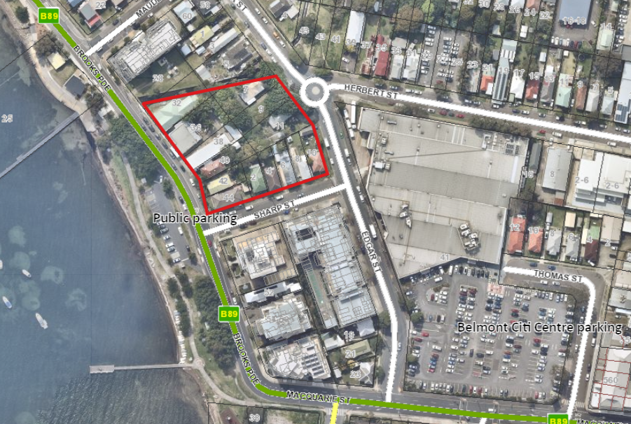
Figure 11 – Location of additional car parking within vicinity of development

6 Development Design
Design of the development is addressed under the relevant sections of the Belmont Town Centre Area Plan and ADG.

6.16 Views
Existing development to the east of the site consists predominantly of single level dwellings that do not gain lake views due to the flat topography. The development will, by the nature of its scale, have an impact on future views available across the site in the event that properties to the east are redeveloped in accordance with the B2 zoning of the land.
The Belmont Town Centre Structure Plan identifies a significant view corridor along Sharp Street that will not be affected by the proposal. Additionally, the layout of the development incorporates a viewing corridor through the site from east to west that will facilitate Lake views from some properties.
In assessing the impact on views, the principles established in Tenacity Consulting v Warringah Council have been considered, in particular whether the development is reasonable for the site. An assessment against the relevant planning controls. The development generally reflects the site layout contained within the Block Plan of the Belmont Town Centre Area Plan as well as other applicable planning controls. As such it is considered to be a reasonable response to the site and impacts on future views are considered acceptable.

6.17 Balconies and communal open space
Each unit is provided with a balcony accessed from internal living areas with areas detailed on Plan DA51. The ADG requires primary balconies as follows:
Dwelling Type | Minimum area | Minimum depth
1 bedroom apartment | 8m² | 2m
2 bedroom apartment | 10m² | 2m
3+ bedroom apartment | 12m² | 2.4m

All units meet and most significantly exceed the minimum area requirements, however the balconies of the 3 bedroom units have a maximum width of 2.15m rather than the 2.4 specified under the ADG. Despite the variation, these spaces are considered to provide good usability and amenity owing to their increased size.
Communal open space is provided at ground/podium level (1498m²) as well as rooftop terraces on each building (542m²). This accounts for 32% of the site area, exceeding the 25% required under the ADG.

6.19 Solar access and orientation
Overshadowing of Belmont Towers to the south of the site was raised as a concern when previously reported to the RPP, particularly in relation to the building height variation sought for Building A. The development is supported by shadow diagrams (both in plan and elevation) demonstrating that neighbouring properties receive well in excess of the minimum 3 hours direct solar access required. It is noted that Building A has had one storey removed.
Solar access within the development meets ADG requirements with 73% of units achieving 3 hours of solar access to balconies and living areas.

6.21 Visual privacy
Visual privacy within the development is achieved through building separation and provision of screening devices. Plan DA06 and DA07 show the development layout in relation to ADG separation distances. In areas where compliance with the required 12m and 18m separation distances between habitable rooms is not strictly achieved, privacy screens have been provided.
As the is bounded on three sides by streets and a drainage channel on the fourth side, adequate separation from neighbouring properties is able to be achieved.

6.25 Safety and security
The development has been designed in accordance with the principles of Crime Prevention Through Environmental Design (CPTED). In particular,
- Access to residential components of the development such as residential towers, residential car parking area and central courtyard areas will be secured to prevent unauthorised access.
- Access to public spaces, including commercial tenancies and the resident/visitor car parking area is clearly defined and delineated from private areas, and
- Way finding signage will be installed to prevent excuse making behaviour.
Good passive surveillance is provided in common areas, however it is recommended CCTV be installed within the basement where surveillance opportunities are limited. In addition, post boxes should be installed within lobby areas and not on the street frontage to discourage theft and vandalism. Lighting will be required throughout the development to aid in the safety of communal spaces at night.
Conditions of consent are recommended for these outcomes.
The application was referred to NSW Police who did not respond during the assessment period.

8.1 Demolition and construction waste management and 8.2 Operational waste management
Waste storage rooms are located within the basement for both residential apartments and commercial tenancies. Waste will be collected by a private contractor from the loading dock and turning platform in Sharp Street.
An adequate waste management plan has been submitted detailing demolition and construction waste, as well as operational waste management. Conditions of consent are recommended to ensure compliance with this plan.

8.5 Erosion and sediment control
Adequate erosion and sediment control measures will be implemented during construction. Conditions are recommended.

8.6 Air quality
The development does not propose used that inherently create air quality issues (i.e. commercial premises and residential flat building).
However the site is located adjacent to a Hunter Water sewer pumping station. Concern was raised by Hunter Water that odours from the sewer pumping station facility may impact the residents of the development. Consequently the applicant commissioned an odour assessment which was submitted to Hunter Water for review. Hunter Water are satisfied odours will not affect the development without the need for mitigation measures. Hunter Water will continue with annual assessment of their facility to ensure it operates effectively.

8.7 Noise and vibration
The development is supported by an acoustic assessment addressing potential impacts of the development on neighbouring residents. This assessment concludes noise generated through the use of the development, including the loading dock located on Sharp Street is within acceptable limits as assessed under the NSW EPA Noise Policy for Industry.
Internal noise levels within the development have also been assessed, specifically in relation to road noise and noise associated with the loading dock directly adjoining apartment G01 in Building A. Recommendations have been made in relation to building materials and construction techniques to ensure amenity is maintained.
Conditions of consent are recommended requiring an Acoustic Consultant endorse the design plans prior to the CC being issued.

Part 13: Residential Flat Buildings

13.1 Site requirements
The amalgamated site has an area of 6379 m² with direct street frontage to Brooks Parade, Sharp Street and Edgar Street. The site meets DCP requirements.

13.2 Housing mix
The development provides 120 apartments comprising the following mix:
- 34 x 1 bedroom units (28%) – maximum 30% permitted;
- 52 x 2 bedroom units (43%) – minimum 40% required;
- 34 x 3 bedroom units (28%) – minimum 15% required.
The mix meets DCP requirements.

13.13 Adaptable dwellings
The development requires 12 adaptable units be provided which are designed and constructed to include the essential features listed in Appendix A of AS4299. 15 units are shown as being adaptable with pre and post adaptation floor plans shown. Adequate accessible parking spaces are provided within the basement to support these apartments. Further, due to the replication of floor plans additional units are able to be adapted pending requests during pre-sale.

Part 10.2: Belmont Town Centre Area Plan

2.1 Block Controls
The site is located within Block C as shown in Figure 11 below. Compliance with the provisions of the Block Plan are detailed under below.
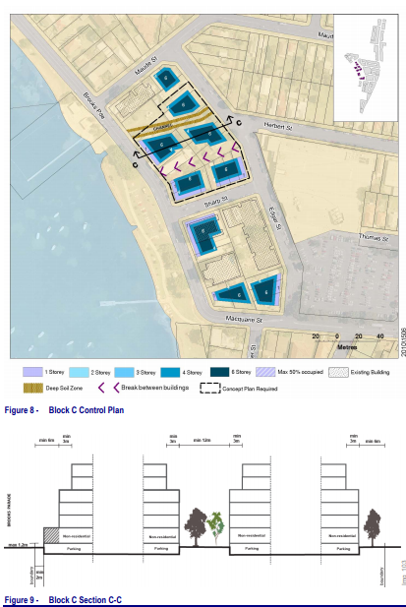
Figure 11 – applicable Block Plan for the site

4.1 Outlook to the lake
The development does not impact on significant views identified within the Structure Plan, which are predominantly obtained down road corridors.
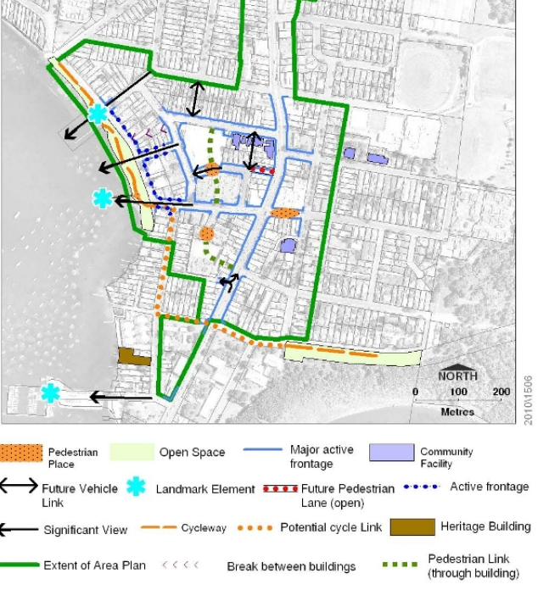
Figure 12 – Belmont Town Centre Structure Plan

6.1 Brooks Parade and Edgar Street and 6.3 Front setbacks
The development is generally consistent with the details provided within Block Plan C.
The development includes a podium level to accommodate flooding constraints, presenting commercial/retail elements to Brooks Parade, Sharp Street and Edgar Street with residential apartments above.
Building C in the north-east corner of the site is the only wholly residential building within the development and has a setback from Edgar Street of 4.38m. This is below the 6m shown on the Block Plan section, however compliant with front setback requirements applicable to B4 zones in Part 4 of DCP 2014. This building is considered to achieve an acceptable built outcome consistent with the remainder of the development.
Setbacks for Buildings A, B and D from street frontages vary from 2m for single-story commercial/retail spaces fronting Edgar Street and Sharp Street, to over 8m to the retail spaces fronting Brooks Parade. The increased setback to Brooks Parade provides opportunities for deep soil planting and outdoor decking to facilitate outdoor dining options.
Following deferral of the application by the RPP in October 2018, several workshops have been held between the DRP, Council officers and the applicant to resolve general design principles, siting and layout. The development is consistent with the outcomes of these workshops and discussions.

6.5 Building height
Building height is addressed under LMLEP clauses 4.3 and 4.6.

6.7 Building exteriors
An external materials and colour schedule is included on Drawing No. DA52-F.
The exterior materials of the development include a combination of face brickwork, painted render, zinc cladding, aluminium louvres and glass balustrades.
The colour palette uses predominantly natural and muted tones with small accents of colour.
The building exteriors are considered appropriate.

7.1 Planting on private land
Landscaped areas exceed 20% of the site area and include the provision of trees within the street setbacks to provide scale and partial screening of the development. Landscape treatments to rooftop terraces are also proposed.
Landscaping design has been reviewed by Council’s Landscape Architect and is considered satisfactory.

Section 4.15 (1) (a) (iv) any matters prescribed by the regulations
The application proposes demolition works. Conditions of consent will be imposed to ensure these works are undertaken in accordance with relevant standards.

Section 4.15 (1) (b) the likely impacts of the development

The likely impacts of the development contained in this part of the Act have been detailed throughout the assessment report.
Due to the scale of the development it is likely there will be a prolonged construction timeframe which may cause amenity impacts and inconvenience to neighbouring residents. A condition of consent is recommended requiring a detailed Construction Management Plan to be prepared detailing methods of limiting impacts.

Section 4.15 (1) (c) the suitability of the site for development

Does the proposal fit the locality?
The development is considered to fit the locality. The development is consistent with the surrounding land uses, fits into the existing urban character and poses no significant adverse impacts.

Are the site attributes conducive to development?
As demonstrated in this report, the site is conducive to the development proposed.

Section 4.15 (1) (d) any submissions made in accordance with this Act or the Regulations?

Public submissions:
The application was notified on three occasions as follows:
- 23 January 2017 – 27 February 2017
- 7 September 2018 – 26 September 2018
- 2 January 2020 – 31 January 2020
Over the three submission periods a total of 30 submissions were received from 19 parties. 29 of these submissions objected to the proposal, and one submission was made in support.
Key issues raised within the submissions are as follows:
- Compliance with planning controls (LMLEP 2014 and DCP 2014)
- Building height, including justifying increased height relative to Belmont Tower development from 1960s*
- Loss of views
- Visual impacts
- Loss of vegetation*
- Adequacy of car parking for commercial/retail units
- Impact of loading dock on Sharp Street streetscape and amenity of neighbouring properties*
- Viability of the development*
- Access to basement car park and potential queuing impacts*
- Acid sulphate soils
- Affordable housing
- Construction impacts and public safety*
- Impacts of increased traffic movements and on-street parking*
- Increased overshadowing to the south due to increased height*
- Amenity impacts (privacy, loss of views) on residents to the south
- Accessibility of visitor parking spaces*
- Apartment mix - number of one-bedroom apartments*
- Impacts of waste collection*
- Safety and security*
- Impacts of lighting*
- Setbacks to Sharp Street and Brooks Parade*
*issue raised in latest notification period
These matters have been considered and are addressed within the relevant sections of this report.

Section 4.15 (1) (e) the public interest
It is considered the proposed development is in the public interest.
The application provides a development that is consistent with the zoning of the land and has demonstrated compliance with relevant controls. Where variations exist, the development has demonstrated no significant amenity impacts will arise now or in the future, subject to the imposition and compliance with recommended conditions of consent. This includes a submission under clause 4.6 exceptions to development standard’ in relation to the maximum building height limit applicable to the site.

Section 7.11 Contribution towards provision or improvement of amenities and services
The site is located within the Belmont Catchment Contribution Plan.
The application was referred to Council’s Development Contributions Officer who provided levies under 7.11 on the basis of the following:
- A total of 120 dwellings as follows:
  - 34 x 1-bedroom dwellings
  - 52 x 2-bedroom dwellings
  - 34 x 3-bedroom dwellings
- Credit for 15 lots
Levies applicable to the development at the date of this report are $1,513,604.53

Staff endorsement
The staff responsible for the preparation of the report, recommendation, or advice to any person with delegated authority to deal with the application has no pecuniary interest to disclose in respect of the application.
The staff responsible authorised to determine the application have no pecuniary interest to disclose in respect of the application. The report is enclosed and the recommendation therein adopted.
Signed:
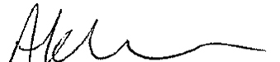
Anna Kleinmeulman
Senior Development Planner
Development Assessment and Certification

Senior Endorsement
The staff responsible for the preparation of the report, recommendation, or advice to any person with delegated authority to deal with the application has no pecuniary interest to disclose in respect of the application.
The staff responsible authorised to determine the application have no pecuniary interest to disclose in respect of the application. The report is enclosed and the recommendation therein adopted.
Signed:
Amy Regado
Acting Chief Development Planner
Development Assessment and Certification

